INDUSTRIAL, MANUFACTURING, & SYSTEMS ENGINEERING
Mount Franklin Foods Machine OEE Improvement
PROJECT SUMMARY

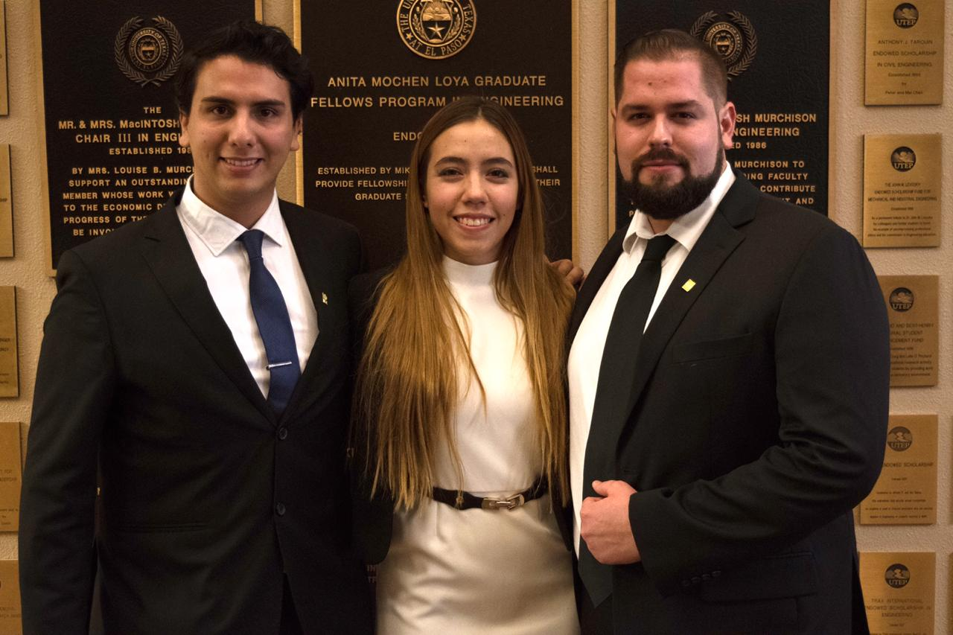

Team Members
Miguel Castro
Aime Valdez
Andres Hernandez

Instructor: Dr. Luis Rene Contreras
Fall 2018
Project Objectives
The primary objective of the project is to improve the Toyo’s OEE, implement engineering methods to help planning the forklift’s usage, accommodation of the upcoming product and lean tools to help on the set up when the machine changes product. The lack of standards for this processes is another problem the team will try to attack in order to help reduce the time needed to change products on the machines. Current state of the machines Net Bags per Minute Short are of 5 bags.
Methodology
In order to identify the Sources of Loss for the machines the team will be working on they will follow the DMAIC methodology, the purpose of following this methodology is to properly identify the sources of loss and leave them documented in case the company later decides to make use of other different types of tools to improve them
Sources Of Loss
To identify the sources of loss the team performed twelve different time studies during the work hours of the TOYO machines, this consisted of staying there for approximately an hour and measure the down times, these where later categorized and allocated on their respective categories, after they were identified the team made use of statistical analysis to rank them and find a SOL where the improvement efforts would be more efficient
Analyze
Once the data was collected the next step was to make use of statistical process control tools to convert data into information, for this purpose the team under the guidance of the industrial partner decided to make use of pareto charts, the information was combined into a single chart to find the biggest source of loss and focus the efforts on this. 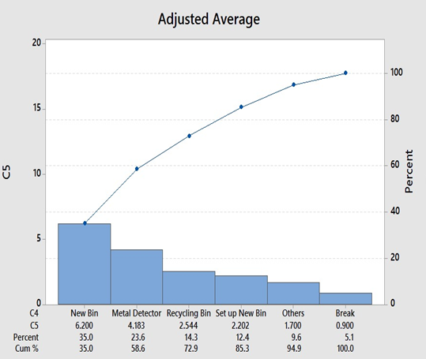
The pareto chart clearly reveals that the biggest source of loss is the change over of the bin which moved the focus of the project from the TOYO machines to the 160 area which is responsible of taking the bins to the machines
Improvement Phase
First Proposed Action.
First improved action would be to follow the 5 S methodology to rearrange the area. However, there was a constraint. Product is not arranged by machine or weighted by the usage, it is arranged by classification of allergen, thus for this is not a feasible option
Second Proposed Action
Change the Kanban system to one that does complies with ADA and gives a better visual aid to the forklift driver. The constraint here was that 260 has a process and must comply with SQF Standard, the team must validate that it does complies.
New Standard Operation Procedure in place and compliant with company policies
The new Kanban system must comply with SQF standard, thus for the team made research on this policy and include in the deliverables the necessary tools to validate the compliance with the policy, a SOP was delivered and validated with SQF that redesigned the Kanban system to make it easier for the forklift driver to pick up the correct sacks at the first time, this reducing variation in the process
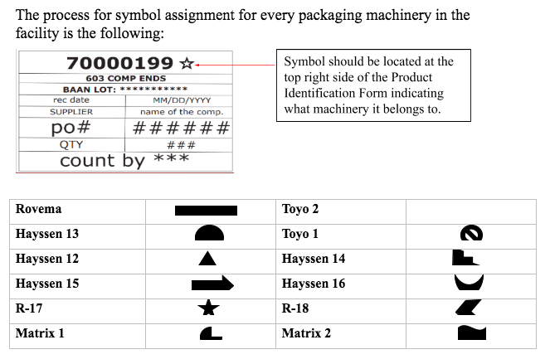

Conclusion
Recalculating the Net bags per minute on the collected data, if we reduce the change over of the bin to 2.5 minutes the expected improvement in NBPM is of 2.03 bags, given this improvement the expectations of elevating from 18 to 23 fell short, however this only considers the TOYO machines and the improvement is expected to exist on all machines, due to lack of data we cannot calculate expected improvement in other machines

